==

NIIT DOCUMENT VIEW

position: absolute;

#6610f2

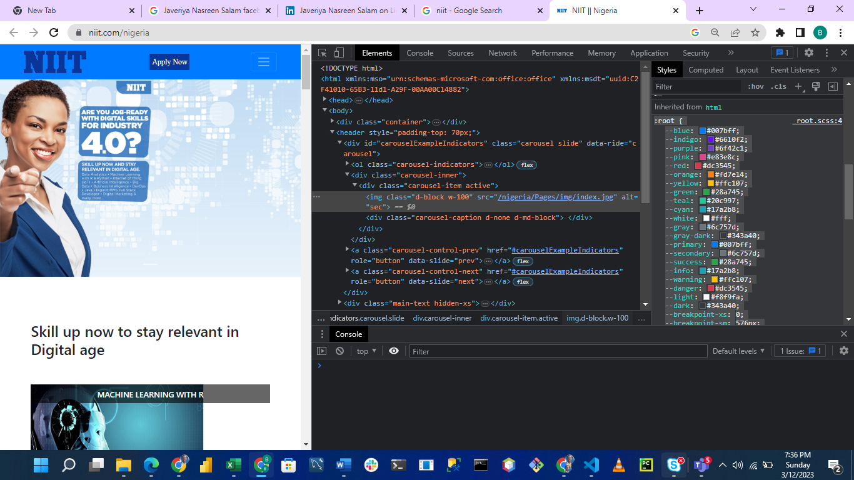

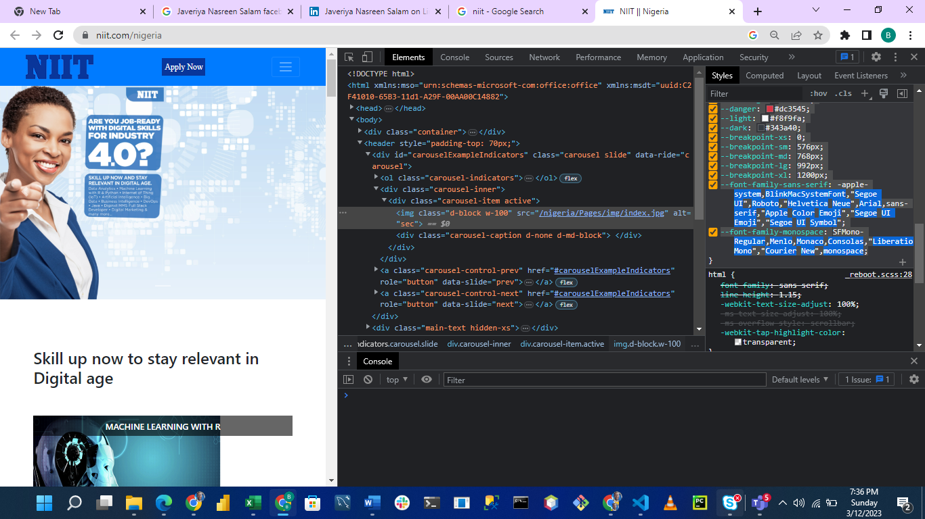

POSITIONING

position: absolute;

.hero__banner__text{

    position: relative;

    width: 30%;

    top: 35%;

    left: 5%;

}

element.style {

}

.w-100 {

width: 100%!important;

}

.d-block {

display: block!important;

}

img {

vertical-align: middle;

border-style: none;

}

*, ::after, ::before {

box-sizing: border-box;

}

user agent stylesheet

img {

overflow-clip-margin: content-box;

overflow: clip;

}

body {

margin: 0;

font-family: -apple-system,BlinkMacSystemFont,"Segoe UI",Roboto,"Helvetica Neue",Arial,sans-serif,"Apple Color Emoji","Segoe UI Emoji","Segoe UI Symbol";

font-size: 1rem;

font-weight: 400;

line-height: 1.5;

color: #212529;

text-align: left;

background-color: #fff;

}

:root {

--blue: #007bff;

--indigo: #6610f2;

--purple: #6f42c1;

--pink: #e83e8c;

--red: #dc3545;

--orange: #fd7e14;

--yellow: #ffc107;

--green: #28a745;

--teal: #20c997;

--cyan: #17a2b8;

--white: #fff;

--gray: #6c757d;

--gray-dark: #343a40;

--primary: #007bff;

--secondary: #6c757d;

--success: #28a745;

--info: #17a2b8;

--warning: #ffc107;

--danger: #dc3545;

--light: #f8f9fa;

--dark: #343a40;

--breakpoint-xs: 0;

--breakpoint-sm: 576px;

--breakpoint-md: 768px;

--breakpoint-lg: 992px;

--breakpoint-xl: 1200px;

--font-family-sans-serif: -apple-system,BlinkMacSystemFont,"Segoe UI",Roboto,"Helvetica Neue",Arial,sans-serif,"Apple Color Emoji","Segoe UI Emoji","Segoe UI Symbol";

--font-family-monospace: SFMono-Regular,Menlo,Monaco,Consolas,"Liberation Mono","Courier New",monospace;